**Apache2 HTTP Server Configuration for Virtual Hosts**

Group 6

WS 2:30 – 4:00

Bautista, Shaira Andrea

Cruz, Julie Leigh

Foz. Viviene

Ramos. Alessandra Nicole

Soriano, Grenalyn

Viray, Jhaylord

Table of Contents

**VIRTUAL HOST CONFIGURATION: Creating Virtual Hosts and mapping of domain names.**

**1**

2

3

**VIRTUAL HOST CONFIGURATION: ENABLING COMPRESSION OF THE CONTENT4**

**VIRTUAL HOST: webtech1.negotiage.org** 5

**VIRTUAL HOST: webtech1.access.org** 6

**VIRTUAL HOST: webtech1.ssi.org7**

**VIRTUAL HOST: webtech1.secure.org** 7

**VIRTUAL HOST CONFIGURATION: Creating Virtual Hosts and mapping of domain names.**

1. After logging in to the ubuntu server, it is required to update the packages in the repository and to install apache2. The command starts with sudo.

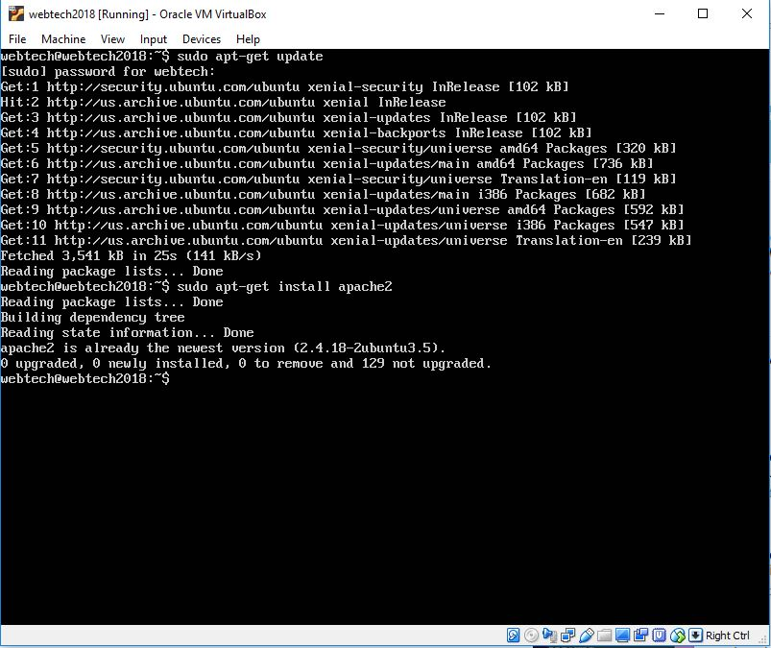

1. Type ifconfig this will show you the network interfaces. The inet address is what you are going to enter in your web browser in the host machine in order to access the default page of Apache2 Ubuntu.

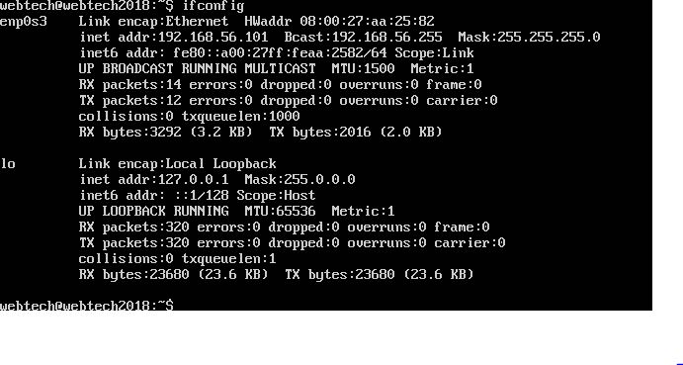

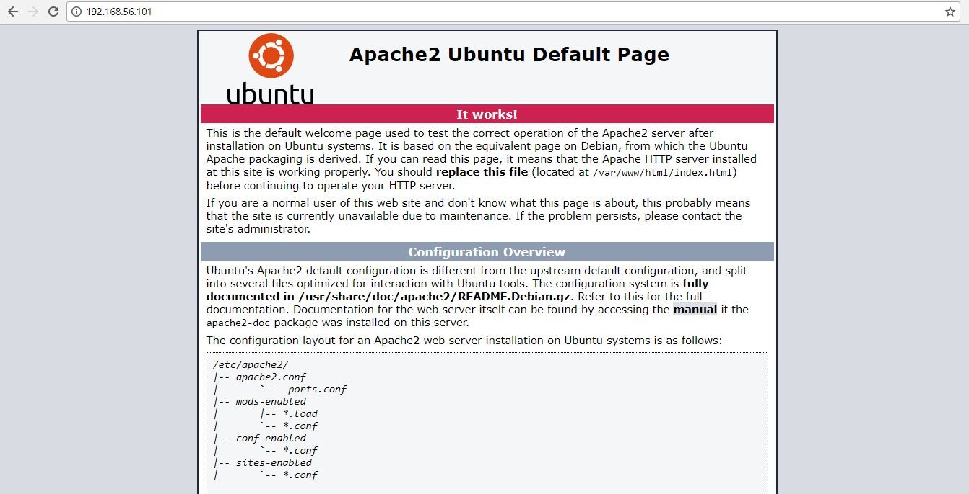

1

1. Configure the network interface by typing the command,

**sudo nano /etc/network/interfaces**.

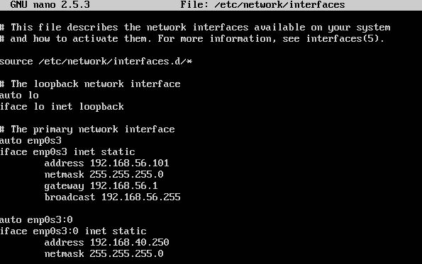

1. In the created directory, create a folder named group6a, group6b and group6c. All files for each site will be saved inside this folder. Once the folder is created ­the user will be prompted to enter a password. Press enter key.

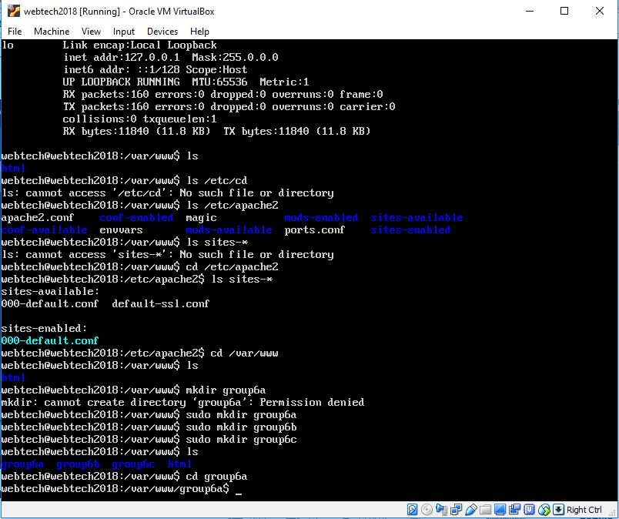

1. Go to each of the created folders and the contents will be the html and css files. To edit a file use sudo nano index.html.



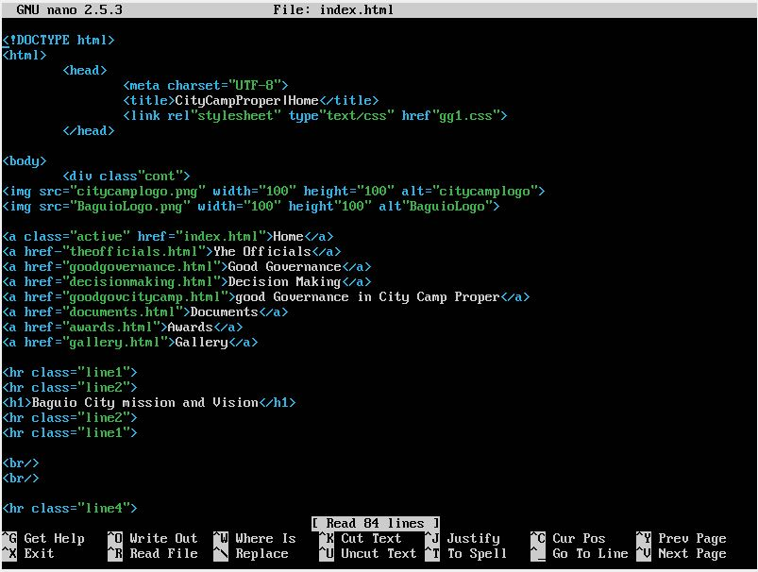

2

1. Next step is to modify the apache2 configuration, type the command, **cd /etc/apache2** inside this are two folders named **sites-available** and **sites-enabled**. Go to sites available and type **sudo nano default.conf** and configure the domain names, [www.group6a.org](http://www.group6a.org), [www.group6a.org](http://www.group6a.org), [www.group6a.org](http://www.group6a.org) and write the server name, server alias and the document root that refers to the folder that was created in step number 4. Type ctrl + x and press y to save and exit.
2. To enable default.conf type, **sudo a2ensite default.conf** command.
3. And disable the 000-default.conf by typing, **sudo a2dissite 000-default.conf**
4. Inside the host machine add the IP address and the domain names inside

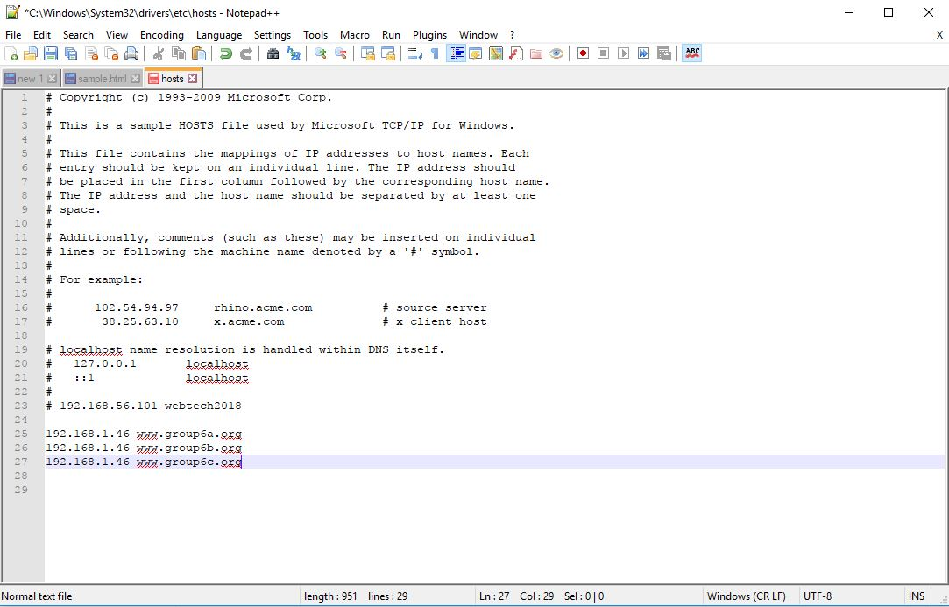

1. Type the IP address or domain name in a web browser on your local machine and it will show you the html file that was saved inside group6a folder, for example.

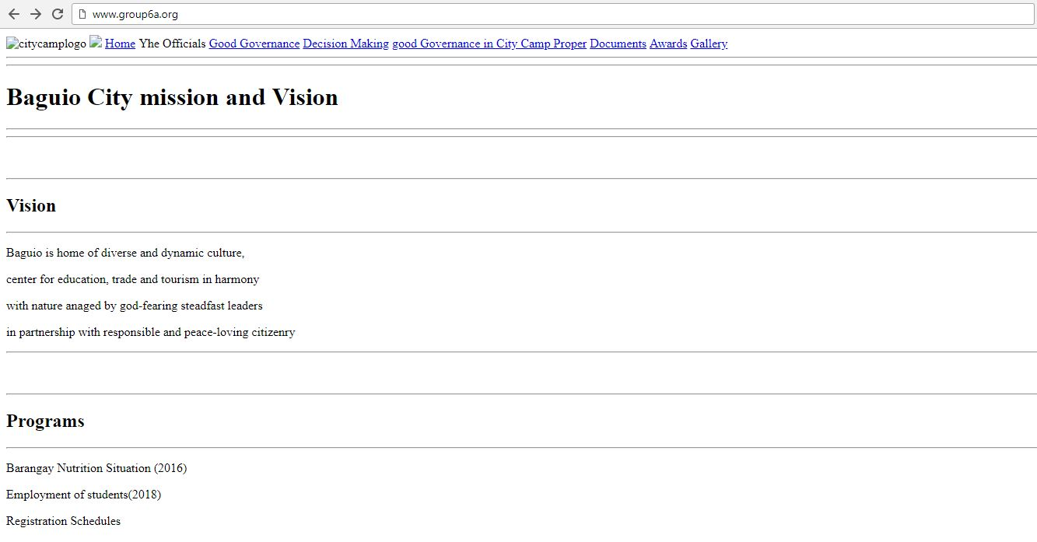

3

**VIRTUAL HOST CONFIGURATION: CONTENT COMPRESSION; CACHING**

1. This is the command to check if mod_deflate module is installed. The output should be deflate_module(shared).

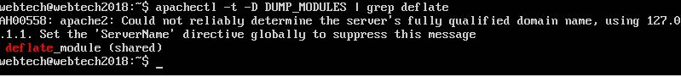

1. For the domain name, [www.group6a.org](http://www.group6a.org) this is the configuration for the compression of content. The configuration includes the limiting of compression to html and css only. And enable caching of PNG, JPG and GIF for 24 hours. Modify the default.conf and add the necessary code starting from the first arrow to the last arrow.

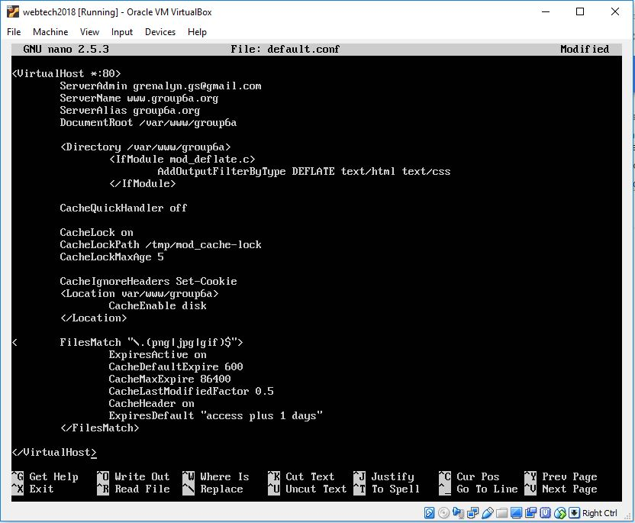

4

**VIRTUAL HOST: webtech1.negotiage.org**

1. Create a folder named webtech.negotiage. This is where the files, content.html and context.html, of the domain name webtech1.negotiage.org will be stored.
2. Inside this folder create 4 dummy files, content.html, content.txt, language.html.en and language.html.fil. To create a file enter **sudo nano language.html.en** for example.



1. After creating the folder and adding the server name webtech1.negotiage.org in the **default.conf**. Go to **cd /etc/apache2/sites-available** and create webtech1negotiate.conf type the following text for the configuration and save.

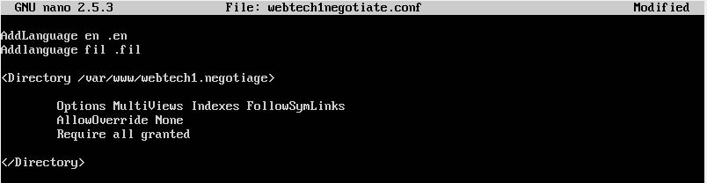

5

**VIRTUAL HOST: webtech1.access.org**

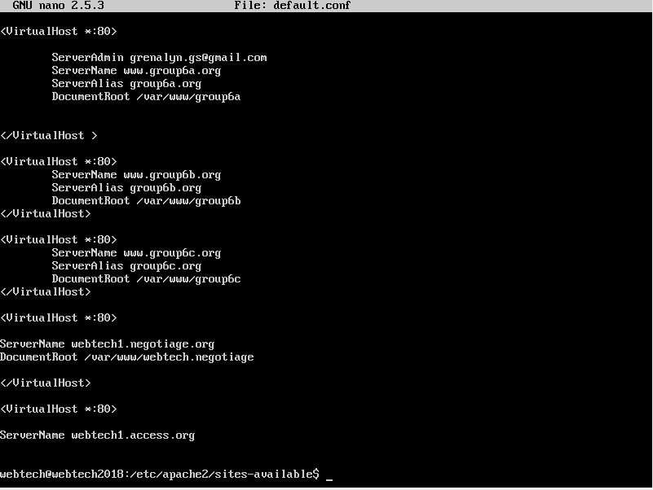

1. Create webtech1.access and inside it create a dummy file create an index.html



1. Configure the webtech1.access.org by typing the text below. Type this in the access.conf and save it.

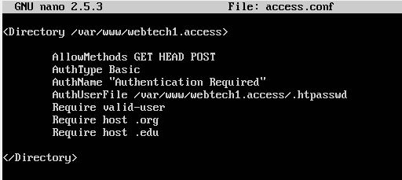

1. This time create password for the users with their id numbers as their usernames. Type **sudo htpasswd -c /var/www/webtech1.access/.htpasswd** **2143553** for the first user. Remove the **-c** in the command when adding another user. Once done with creating users and password type **cat/var/www/webtech1.access/.htpasswd**

To see updated list of users.

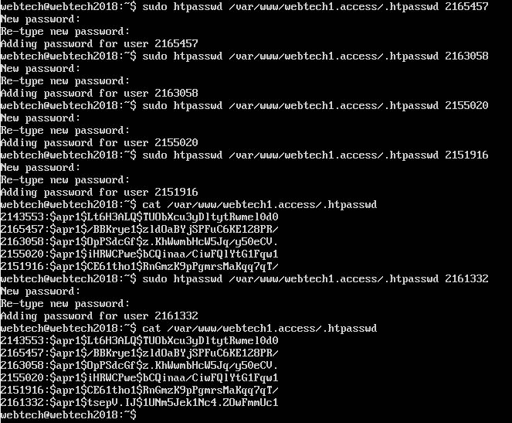

6

**VIRTUAL HOST: webtech1.ssi.org**

1. Create an error.html file inside the webtech1.ssi that will be accessed by the user when they requested a non-existent file.
2. In the default.conf add the following text under server name, webtech1.ssi

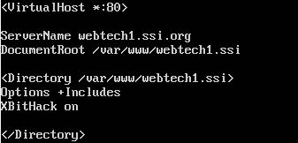

**VIRTUAL HOST: webtech1.secure.org**

1. Create index.html inside the webtech1.secure folder.
2. Enter the command **sudo openssl req -x509 -nodes -days 365 -newkey rsa:2048 -keyout /etc/ssl/private/apache-selfsigned.key -out /etc/ssl/certs/apache-selfsigned.crt**

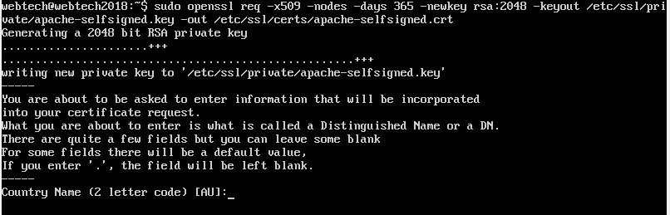

1. Fill up with necessary information

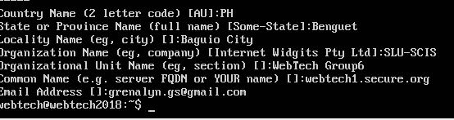

* Enable all created configuration files, with .conf extension, with a2ensite command. For example, **sudo a2ensite compcache.conf**
* Enter the command **sudo service apache2 restart** to restart the server.

7